Advanced CSS (Transition, Transformation, Animation)
In this exercise you will experiment with CSS3 Transformation to create more interactive website. You can find this solution for this exercise in the following folder:
H:\BUSINESS\DISC\6420 IWD\exercises\Advanced CSS Exercise

Instructions
1 | Trying out transitions
In this exercise, we’re going to create the rollover and active states for a menu
Link in the Figure with animated transitions. I’ve put together a starter document
(exercise1.html) for you in the materials folder for this chapter. I recommend that you use a current version of a Webkit-based browser (Chrome or Safari) to view your work.

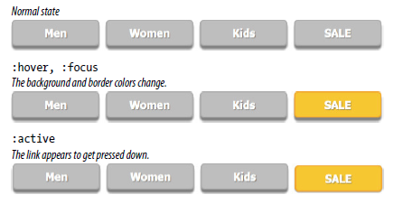

- First, take a look at the styles that are already applied. The list has been converted to a horizontal menu using floats. The a element has been set to display as a block element, underlines are turned off, dimensions and padding are applied, and the color, background color, and border are established. I used the box-shadow property to make it look as though the links are floating off the page.

- Now we’ll define the styles for the hover and focus states. When the user puts the pointer over or tabs to the link, make the background color change to gold
(#fdca00) and the border color change to orange (#fda700).

a:hover, a:focus {
background-color: #fdca00;
border-color: #fda700;
}

- While the user clicks or taps the link (:active), make it move down by three pixels as though it is being pressed. Do this by setting the a element’s position to relative, then change the value the top property for the active state. This moves the link three pixels away from the top edge (in other words, down).

a {
…
position: relative;
}
a:active {
top: 3px;
}

- Logically, if the button were pressed down, there would be less room for the shadow, so we’ll reduce the box-shadow distance as well.

a:active {
top: 3px;
box-shadow: 0 1px 2px rgba(0,0,0,.5);
}

- Save the file and give it a try in the browser. The links should turn yellow and move down when you click or tap them. I’d say it’s pretty good just like that. Even without the box shadows, which is how users of IE8 and earlier will see them, they look and work just fine. Now we can enhance the experience by adding some smooth transitions.

- Make the background and border color transition ease in over .2 seconds, and see how that changes the experience of using the menu. I’m using the shorthand transition property to keep the code simple. I’m also using the default ease timing function at first so we can omit that from the style as well

I’m going to show all browser prefixes on this first example, but if you are using Chrome or Safari, you can just use -webkit- to save time typing. In upcoming examples, I’ll show only the standard, prefix-free property to save space (but the prefixed versions will be there in spirit).

a {
-webkit-transition: background-color 0.2s, border-color 0.2s;
-moz-transition: background-color 0.2s, border-color 0.2s;
-o-transition: background-color 0.2s, border-color 0.2s;
-ms-transition: background-color 0.2s, border-color 0.2s;
transition: background-color 0.2s, border-color 0.2s;
}

- Save your document, open it in the browser, and try moving your mouse over the links (see the note). Do you agree it feels nicer? Now I’d like you to try some other duration values. See if you can still see the difference with a .1s duration. Now try a full second (1s). I think you’ll find that one second is surprisingly slow. I’d worry that people would miss it. Try setting it to several seconds and trying out various timing-function values (just add them after the duration times). Can you tell the difference? Do you have a preference? When you are done experimenting, set the duration back to .2 seconds.

- Now let’s see what happens when we add a transition to the downward motion of the link when it is clicked or tapped. Transition both the top and box-shadow properties because they should move in tandem. Let’s start with a 0.2s duration like the others.

a {
transition: background-color 0.2s, border-color 0.2s, top .2s,
box-shadow 0.2s;
}

Save the file, open it in the browser, and try clicking the links. That transition really changes the experience of using the menu, doesn’t it? The buttons feel more difficult to press. Try increasing the duration. Do they feel even more difficult? I find it interesting to see the effect that timing has on the experience of a user interface. It is important to get it right and not make things feel sluggish. I’d say that a very short transition such as .1 second—or even no transition at all—would keep these buttons feeling snappy and responsive.

- If you thought increasing the duration made the menu uncomfortable to use, try adding a short .5-second delay to the top and boxshadow properties.
a {
transition: background-color 0.2s, border-color 0.2s, top 0.2s
0.5s, box-shadow 0.2s 0.5s;
}
I think you’ll find that little bit of extra time makes the whole thing feel broken.Timing is everything!

2 | Transitioning transforms
In this exercise, we’ll make the travel photos in the gallery shown in the following figure grow and spin out to an angle when the user mouses over them—and we’ll make it smoooooth with a transition. A starter document (aquarium.html) and all of the images are available in the materials folder for this chapter.
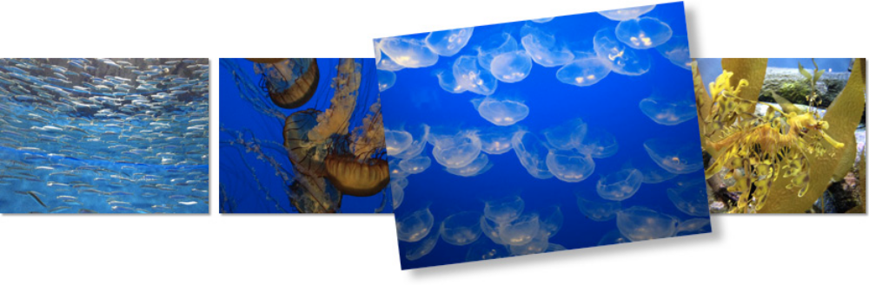

- Open aquarium.html in a text editor, and you will see that there are already styles that arrange the list items horizontally and apply a slight drop shadow to each image. (Note that if you’re not seeing the drop shadow, you’re not using a current browser). The first thing we are going to do is add the transform property for each image.
- We want the transforms to take effect only when mouse is over the image or when the image has focus, so the transform property should be applied to the :hover and :focus states. Because I want each image to tilt a little differently, we’ll need to write a rule for each one, using its unique id as the selector. You can save and check your work when you’re done.

a:hover #img1, a:focus #img1 {
transform: rotate(-3deg);
}
a:hover #img2, a:focus #img2 {
transform: rotate(5deg);
}
a:hover #img3, a:focus #img2 {
transform: rotate(-7deg);
}
a:hover #img4, a:focus #img2 {
transform: rotate(2deg);
}

- Now let’s make them a little larger as well, to give visitors a better view. Add scale(1.5) to each of the transform values. Here is the first one; you do the rest.

a:hover #img1 {
transform: rotate(-3deg) scale(1.5);
}

It is important to note that my image files are created at the larger size and then scaled down for the thumbnail view. If we started with small images and scaled them larger, they would look crummy.
- As long as we are giving the appearance of lifting the photos of the screen, let’s make the drop shadow appear to be a little farther way by increasing the offset and blur and lightening the shade of gray. All images should have the same effect, so add one rule using a:hover img as the selector.

a:hover img {
box-shadow: 6px 6px 6px rgba(0,0,0,.3);
}

Save your file and check it out in a browser. The images should tilt and look larger when you mouse over them. But the action is kind of jarring. Let’s fix that with a transition.
- Add the transition shorthand property to the normal img state (i.e., not on :hover or :focus). The property we want to transition in this case is transform. Set the duration to .3 seconds and use the linear timing function.

img {
…
transition: transform 0.3s linear;
}

Note that in the prefixed versions, the transform property needs to be prefixed
as well. For example, the Webkit version would be:

-webkit-transition: -webkit-transform .3s linear;

And that’s all there is to it! You can try playing around with different durations and timing functions or try altering the transforms or their origin points to see what other effects you can come up with.

3| Animation

I have shown you the css animation example (animationExample1.html). In this exercise, you have to modify the code so that a link can have more effects in its animation.
- You have to make the element rotates 360 degrees along the way
- You have to make it move in the following directions
A hint: you need to use CSS positioning in order to move the element
Move right 100px
Move right 100px

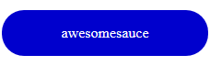
Move down 200px
Move up 100px and left 200px
Move up 100px

